JOBSHEET III

**ARRAY OF OBJECTS**



**From:**

AL AZHAR RIZQI RIFA’I FIRDAUS

**Class:**

1 I

**Absence:**

01

**Major:**

Information Technology

**Study Program:**

Informatic Engineering

# Learning Objective

At the end of this session, students will be able to:

* + 1. Understand and explain the use of Array of Objects
    2. Understand the logic of why we use Array of Objects in Java
    3. Implement Array of Object in Java

# Create, insert, and display Array of Object

In this session, we will have a practice of creating array of object, insert the data, and display it

# Steps

* + - 1. Create a new project with name ArrayOfObjects. Create the package with name ‘week3’
      2. Create a **Rectangle** class:

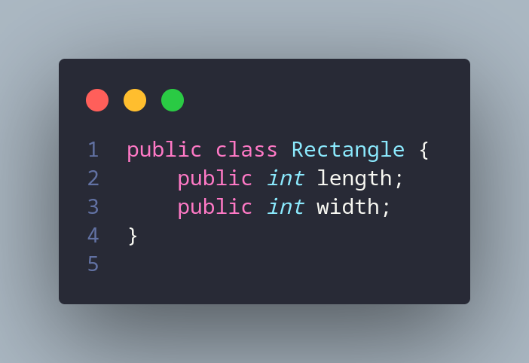

* + - 1. In main method in ArrayOfObjects class, create an array **Rectangle** and its length is 3

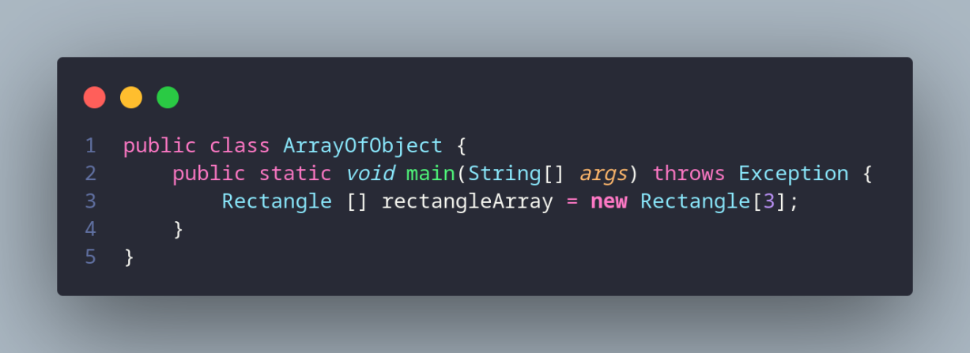

* + - 1. Then insert values for each the object’s attributes

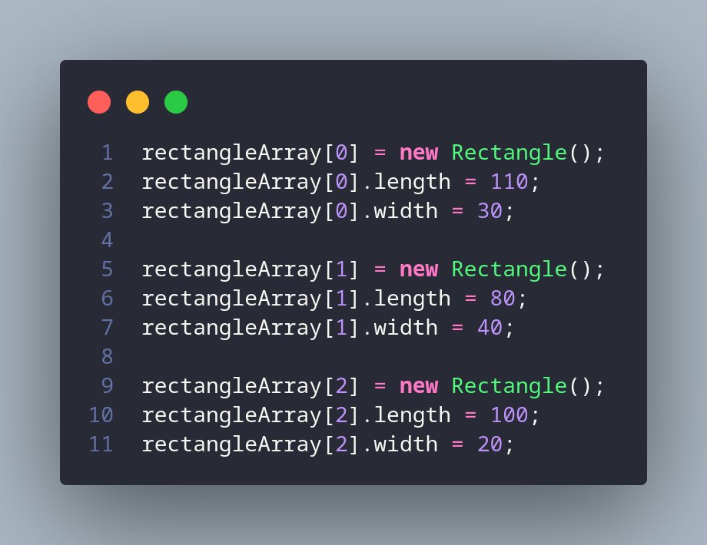

* + - 1. Print all the attributes object from ppArray as follows

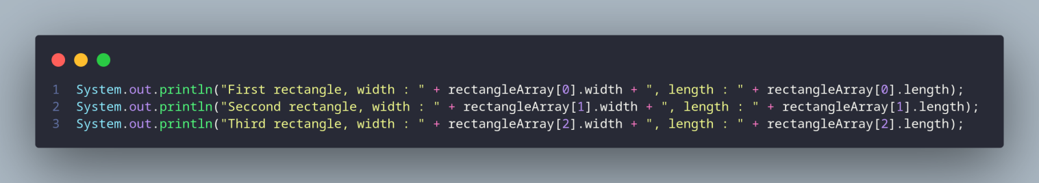

# Result

Compile the code and see the result if it matches with following image.

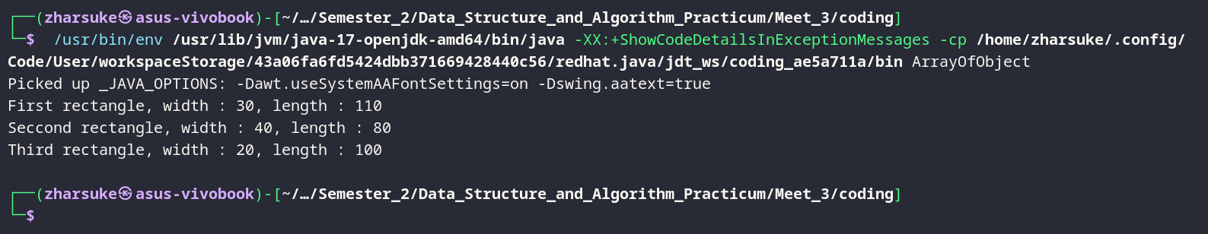

# Questions

* + - 1. Based on practicum 1.2, does the class that are going to be used as an array of object must have attributes and methods? Please explain

Yes, if you want to use a class as an array of objects, the class should have both attributes and methods.

* + - 1. Does class **Rectangle** have constructor? If not, why we instantiate the object as follows?

rectangleArray[1] = new Rectangle();

because if we used constructor, we usually must instantiate with parameter.

* + - 1. What’s the meaning of this line of code?

Rectangle[] rectangleArray = new Rectangle[3];

this line of code instantiate an array of object that have 3 length.

* + - 1. What’s the meaning of these lines of code?

rectangleArray[1] = new Rectangle(); rectangleArray[1].length = 80;

rectangleArray[1].width = 40;

this line of code instantiate index 1 of the array, then sets the length and width properties of this object to 80 and 40.

* + - 1. Why **ArrayOfObject** class and **Rectangle** class should be differentiated?

because both have difference functionality, the function of ArrayOfObject is to create main class, then the function of rectangle class is to store properties of rectangle.

# Get input in Array of Objects using Loops

In this practicum we will update the program result in 1.2 so that the program could receive user inputs and use loops to assign values of each attributes of rectangles in ppArray

# Steps

* + - 1. Import scanner in **ArrayOfObjects** class below the package declaration.

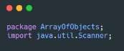

* + - 1. In practicum 1.2 in 4th steps. Change the code as follows, this allows the Scanner object to be included in loops to receive input and assign user input values to the attributes.

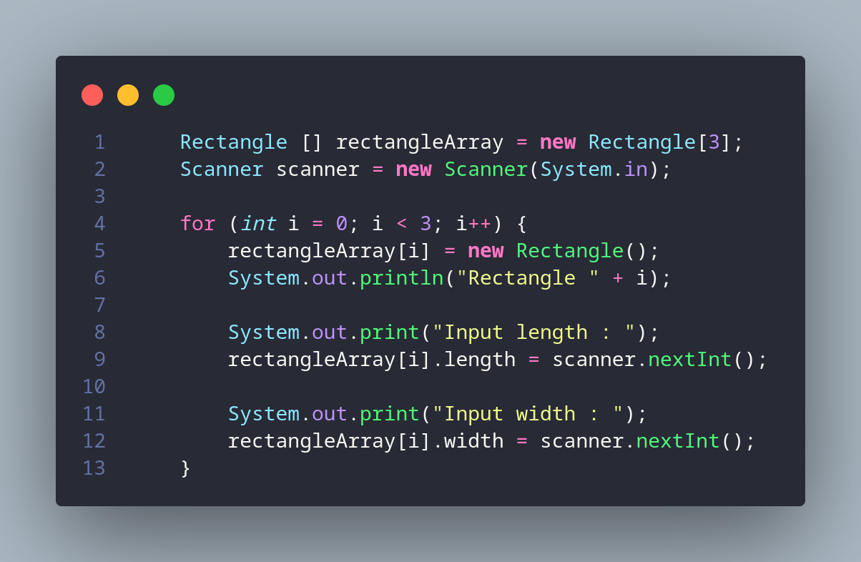

* + - 1. In practicum 1.2 in 5th steps. Change the code as follows. This time, we will use loop to access the element of **ppArray** and print it on the console

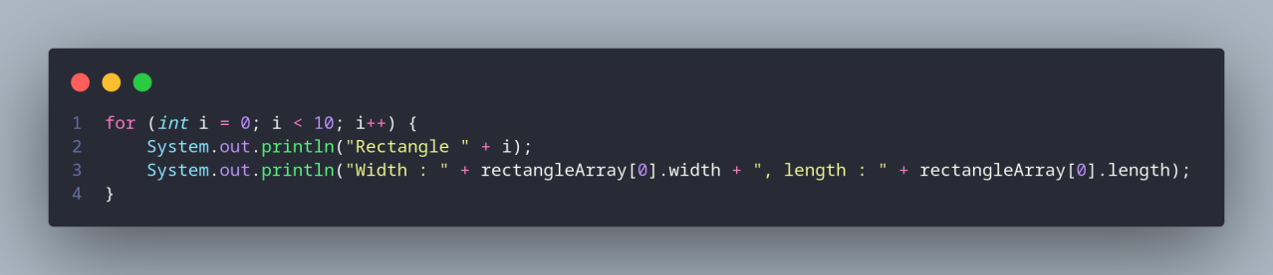

* + - 1. See the result

# Result

Run the program and see if it matches with following result:

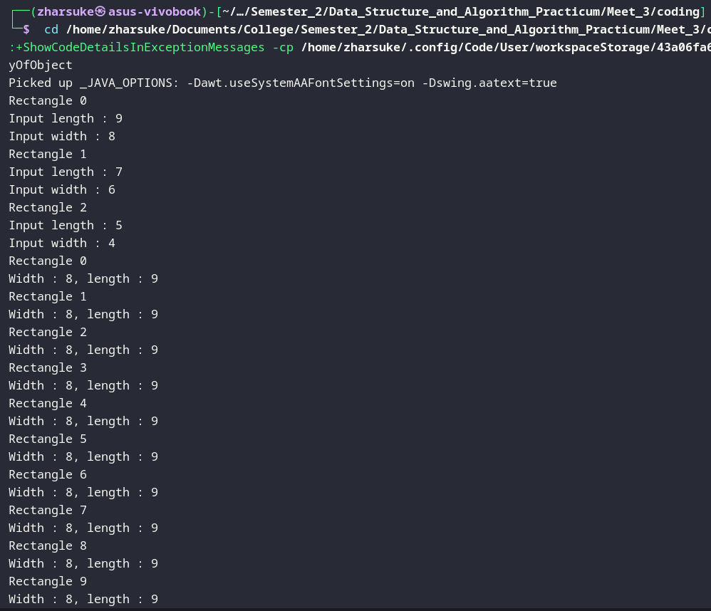

# Questions

* + - 1. Does array of object can be implemented on 2D array?

yes.

* + - 1. If yes, then please give an example. Otherwise, please explain?

An array of objects can be implemented in a 2D array because a 2D array is simply an array of arrays. Each element of the 2D array can be an object, including an array of objects.

Example:

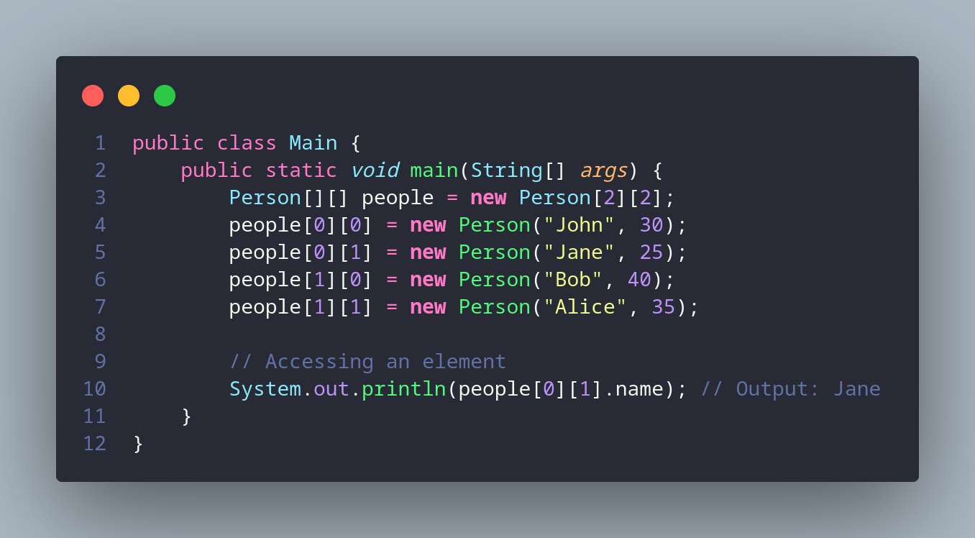

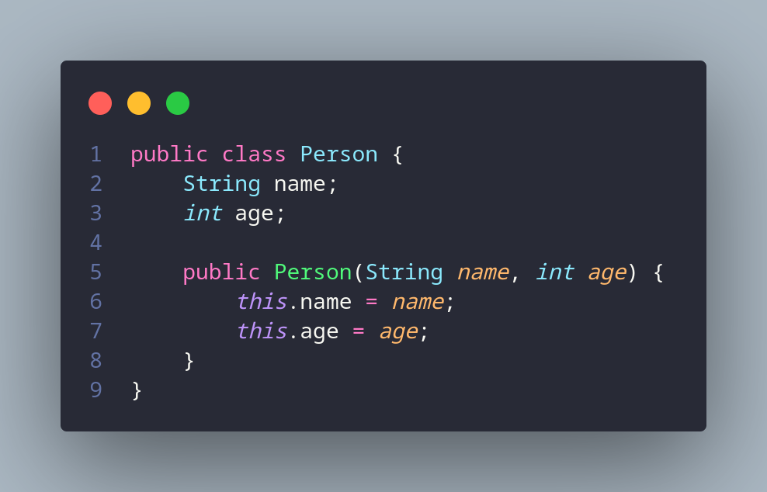

* + - 1. There is a **Square** class that has an attribute **side** with integer as its data type. There will be an error when we run this code, why?

Square[] squareArray = new Square[100]; squareArray[5].side = 20;

There will be an error when running this code because the squareArray[5] element is not initialized before accessing its side attribute.

* + - 1. Modify the code on practicum 1.3 so that the length of the array will be defined from user input

Code:

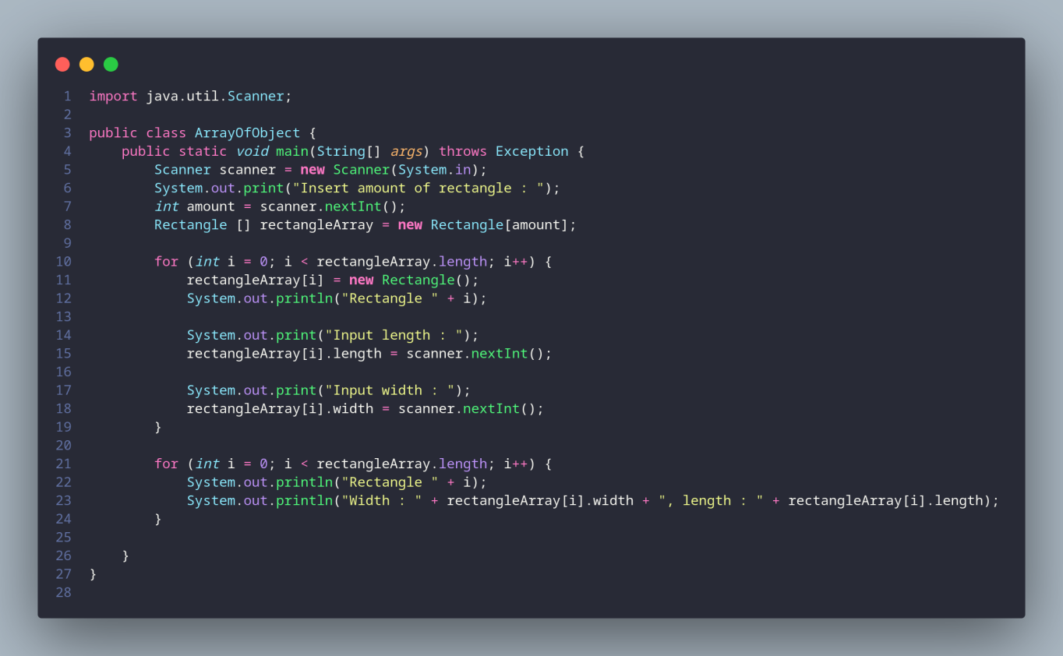

Result:

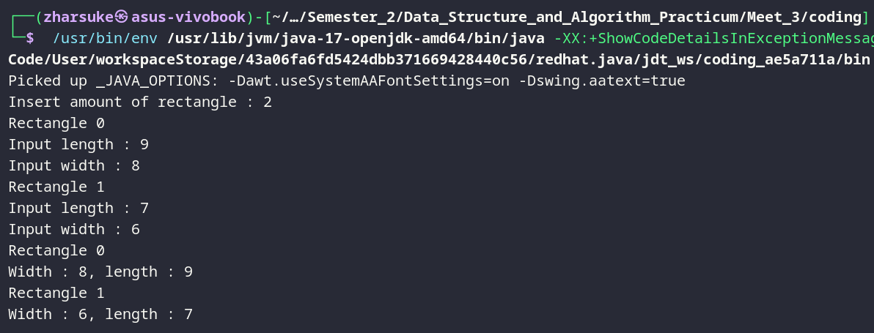

* + - 1. Can we duplicate the instantiation process in array of objects? For example, we assign the object in **ppArray[i]** and **ppArray[0]**, the instantiation process of **ppArray[0]** will be done twice. What’s the effect of this?

If you duplicate the instantiation process of an object in an array, such as assigning an object to both ppArray[i] and ppArray[0], then the effect will depend on the specifics of the code and the class being instantiated.

# Mathematical operation in array of object’s attribute

* + 1. **Steps**
       1. Create a new package called **ArrayBlock**
       2. Create a class named **Blocks**

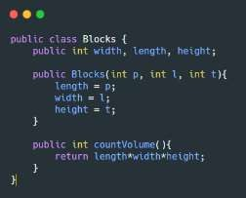

* + - 1. In **main** function in **ArrayBlock,** instantiate array of **Blocks** that has size of 3

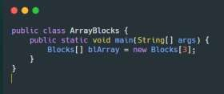

* + - 1. Then add these following codes to insert the value of **blArray** using its constructor

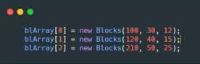

* + - 1. 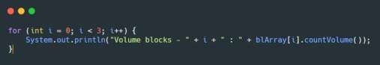Display the volume of all blocks by calling the method countVolume() in loop as follows.
      2. Run and observe the result

# Result

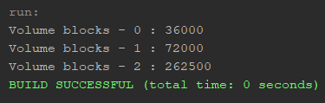Run the program and see if it matches with following result:

# Questions

* + - 1. Can we have more than one constructor in one class? Please explain

Yes, you can have more than one constructor in a class in most object-oriented programming languages. A constructor is a special method that gets called when you create a new object of a class. It initializes the object's state and sets up any necessary resources.

* + - 1. Create a **Triangle** class as follows

public class Triangle{

public int base; public int height;

}

Add another constructor in this class that has parameter **int a, int t**. These represents its base and height.

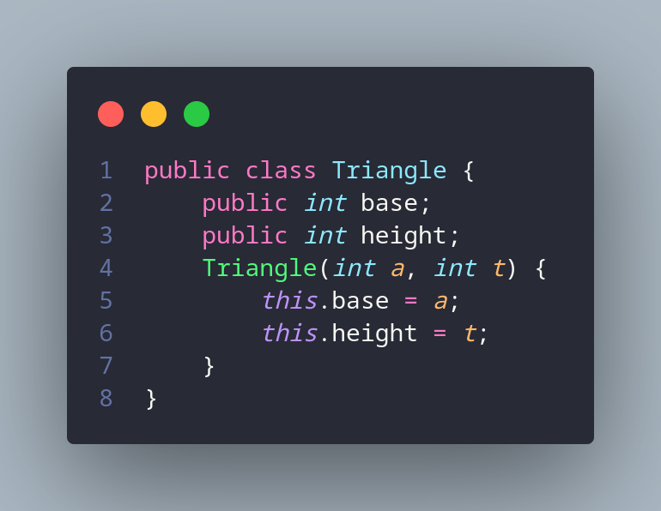

* + - 1. Add method **countArea()** and **countPerimeter()** in class **Triangle**

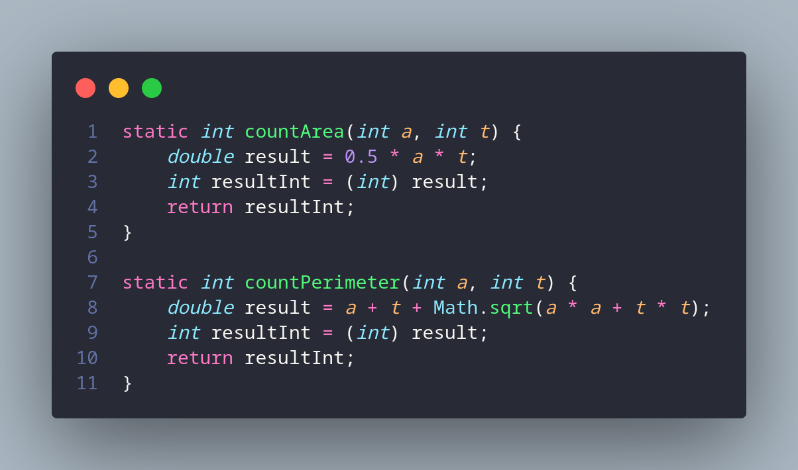

* + - 1. In main function, instantiate array of **Triangle** objects. Assign the attributes values as follows:

0th trArray base: 10, height: 4

1st trArray base: 20, height: 10

2nd trArray base: 15, height: 6

3rd trArray base: 25, height: 10

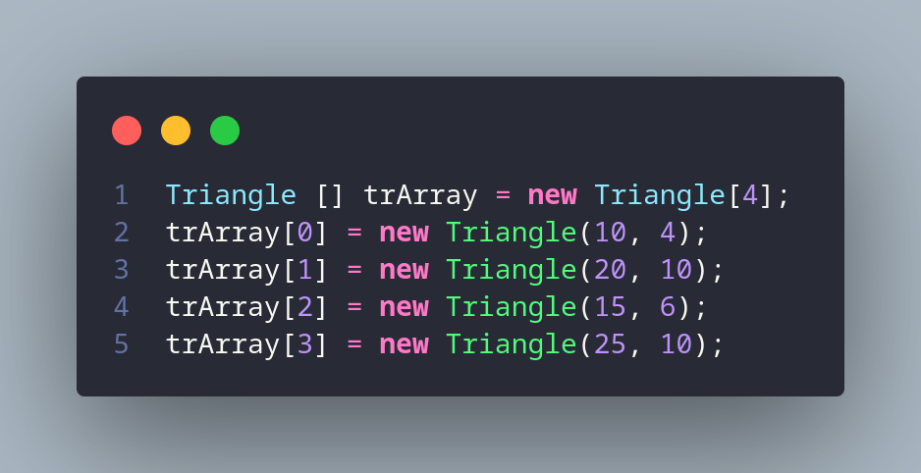

* + - 1. Display the result of area and perimeter for each triangle by calling the method

# countArea() and countPerimeter()

Code:

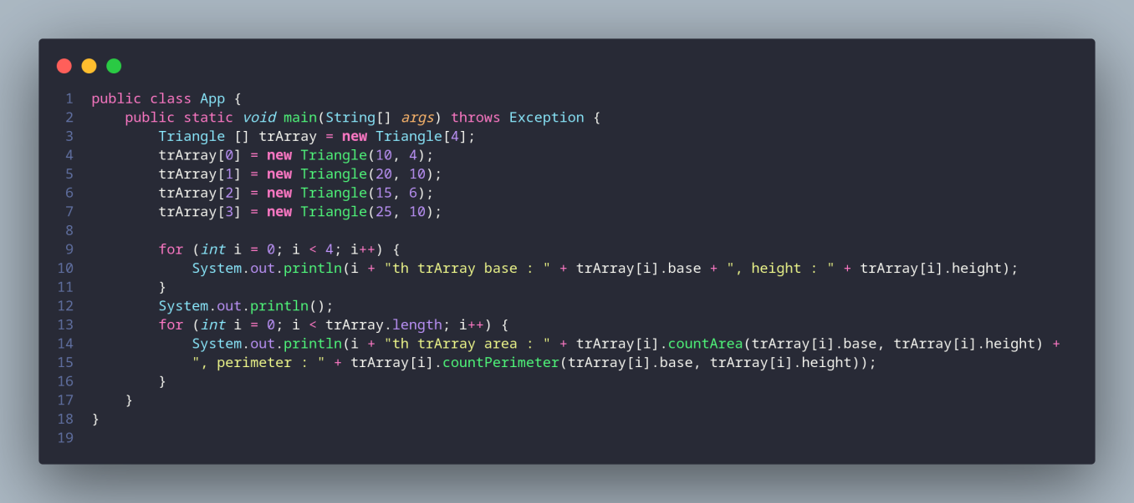

Result:

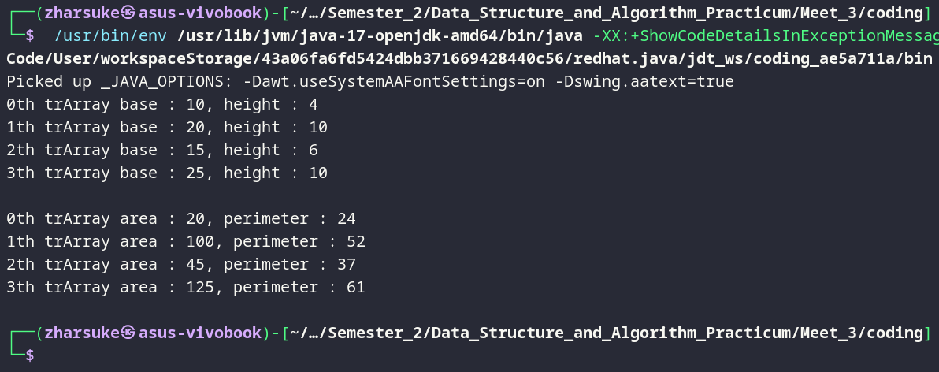

* 1. **Practice**
     1. Create a program that can count surface area and volume of some 3D Geometry object (Cube, blocks, cylinder, etc). Then, create one more class to instantiate the array of objects with its constructor to assign values of its attributes.

Note: Create loop to get user input and assign it to the attributes of the objects, then display the surface area and volume of each 3rd geometry object in console

Code:

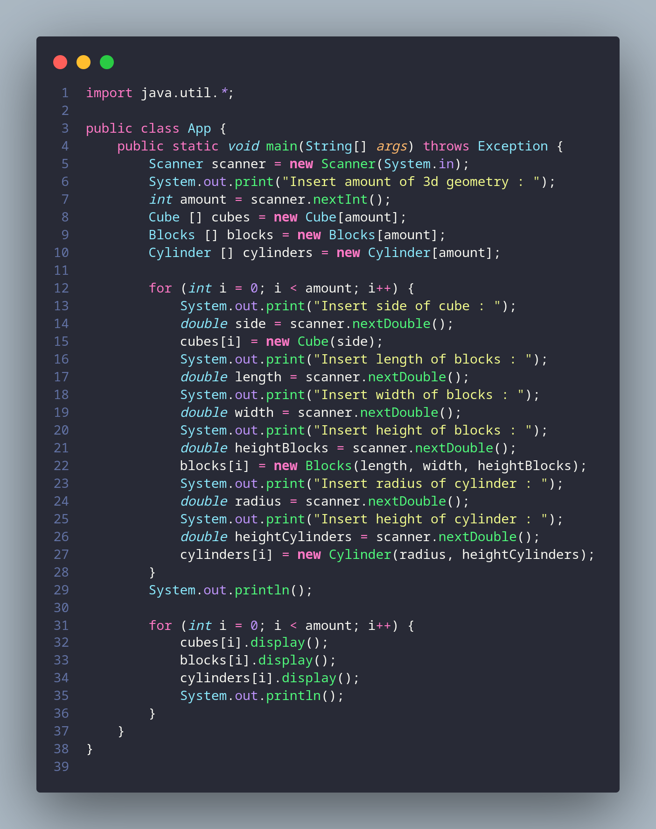

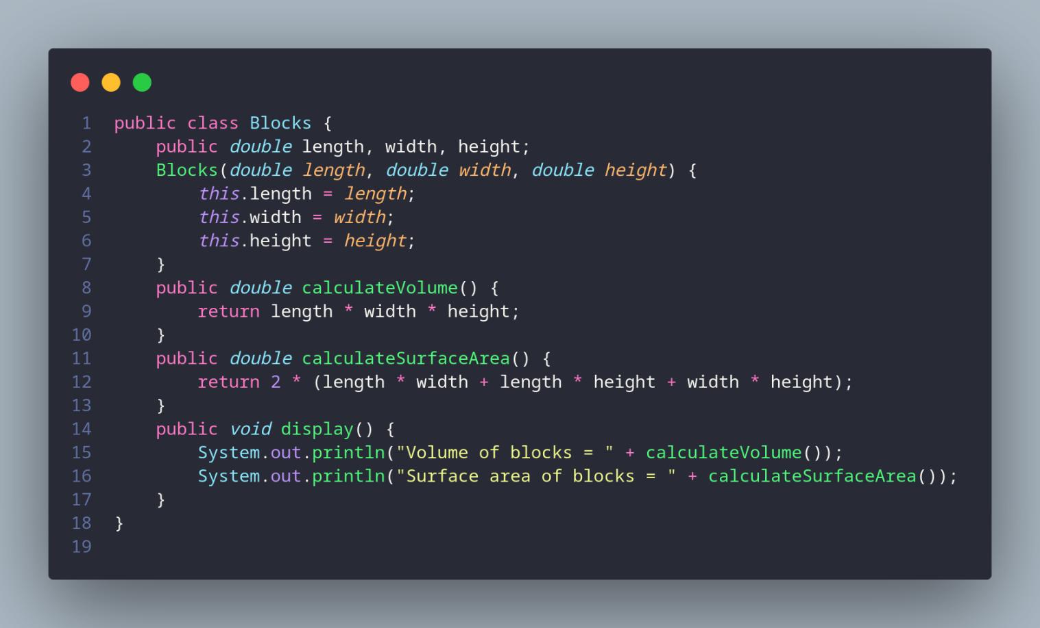

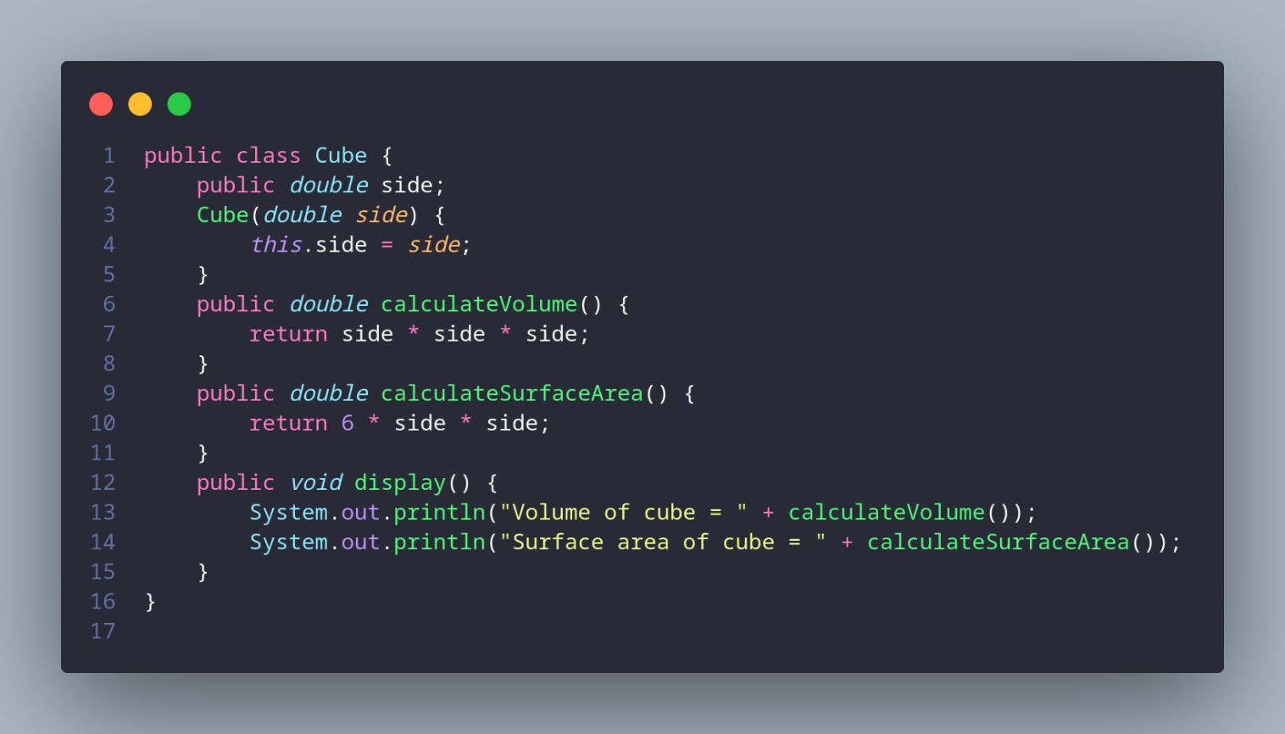

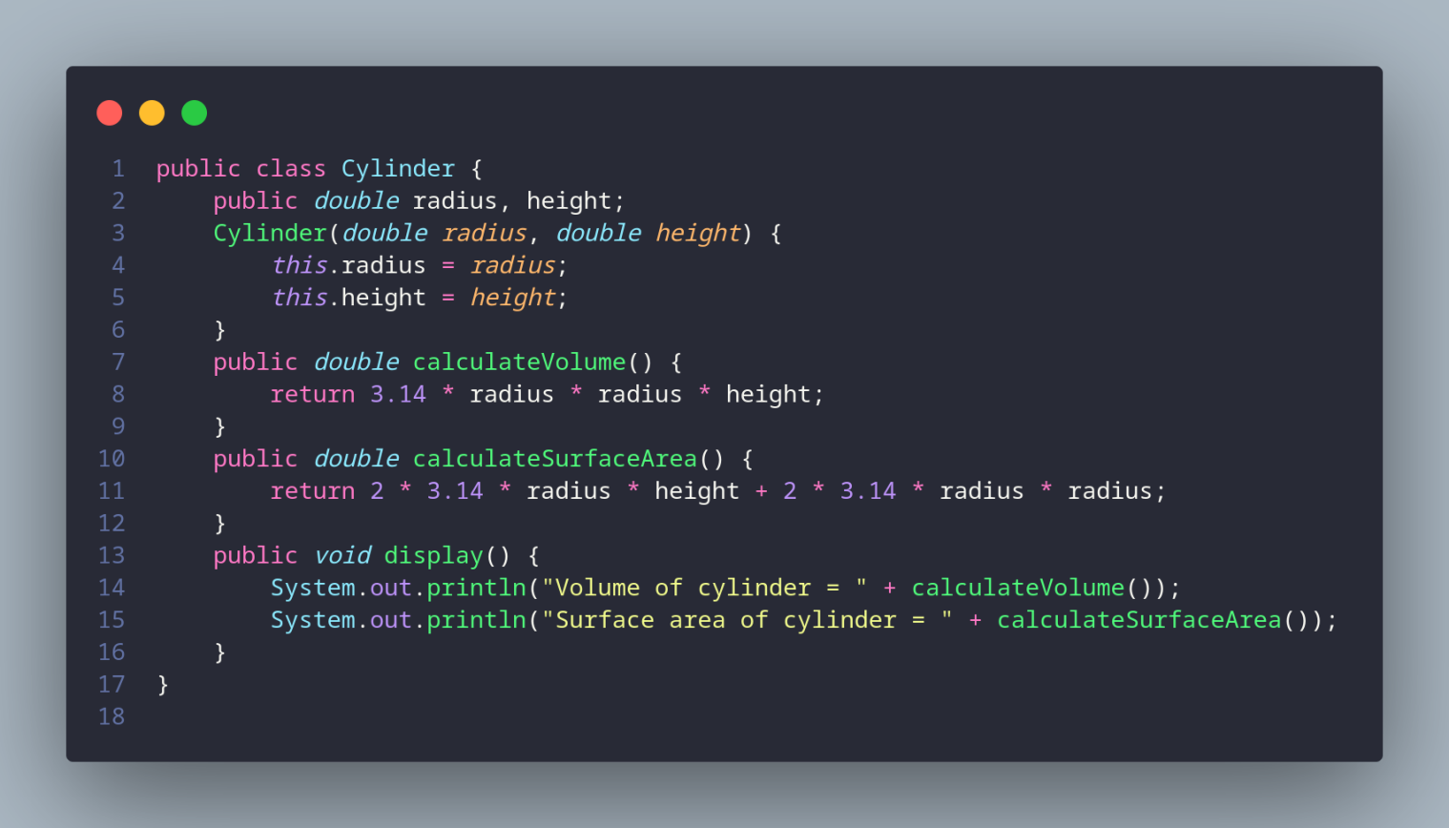

Result:

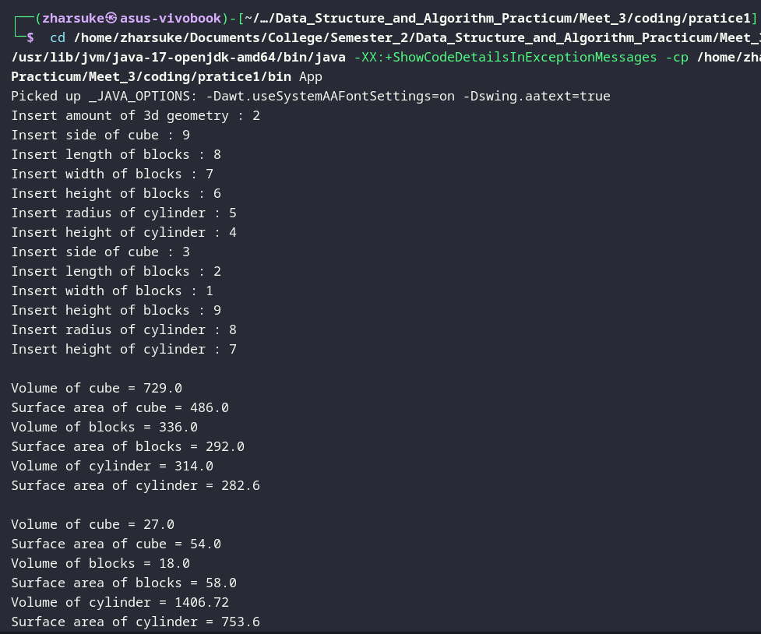

* + 1. A company that handles land transaction needs a program to calculate land area. This program must receive user input to assign values of these:
       - How many lands?
       - Length and width of the land

This program calculates the area of inputted land information as its output. Check this following program:

How many lands: 3

Land 1

Length: 100

Width : 40

Land 2

Length: 250

Width : 100

Land 3

Length: 120

Width : 100

Land Area 1: 4000

Land Area 2: 25000

Land Area 3: 12000

Code:

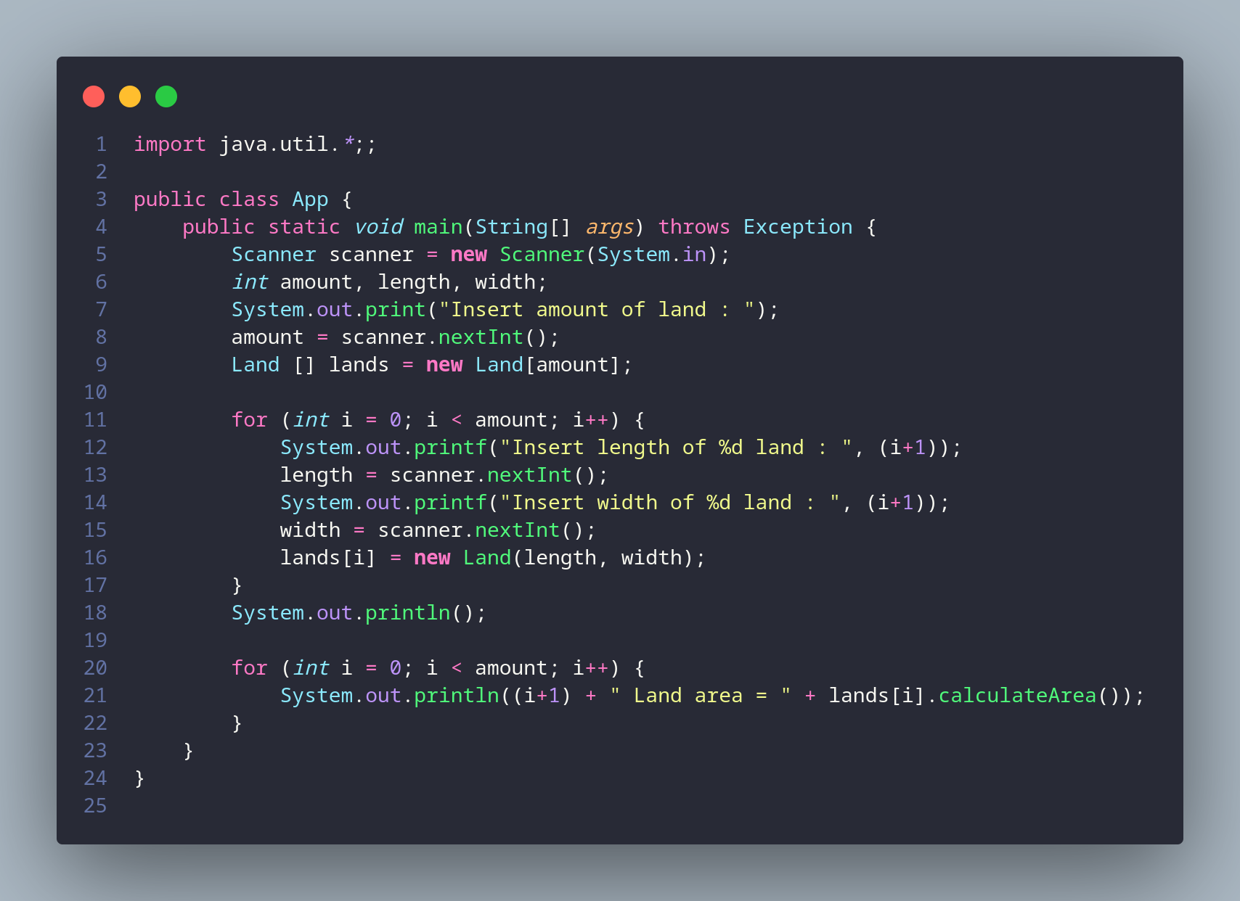

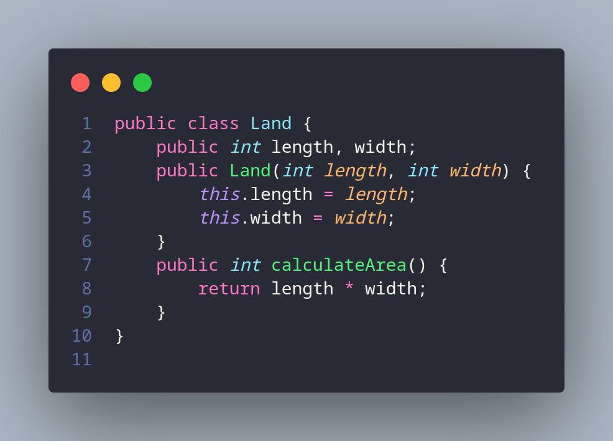

Result:

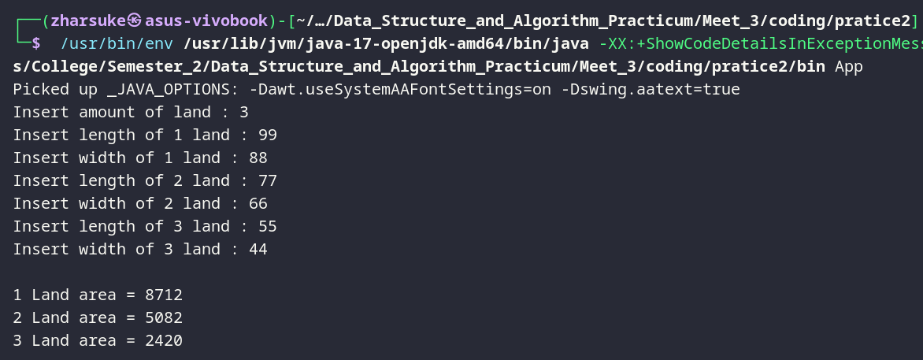

* + 1. Modify the program above so that it can display the widest area. (Additional note: create a different function to get the widest area)

Land 1

Length: 100

Width : 40

Land 2

Length: 250

Width : 100

Land 3

Length: 120

Width : 100

Land Area 1: 4000

Land Area 2: 25000

Land Area 3: 12000

The widest land is Land 2

Code:

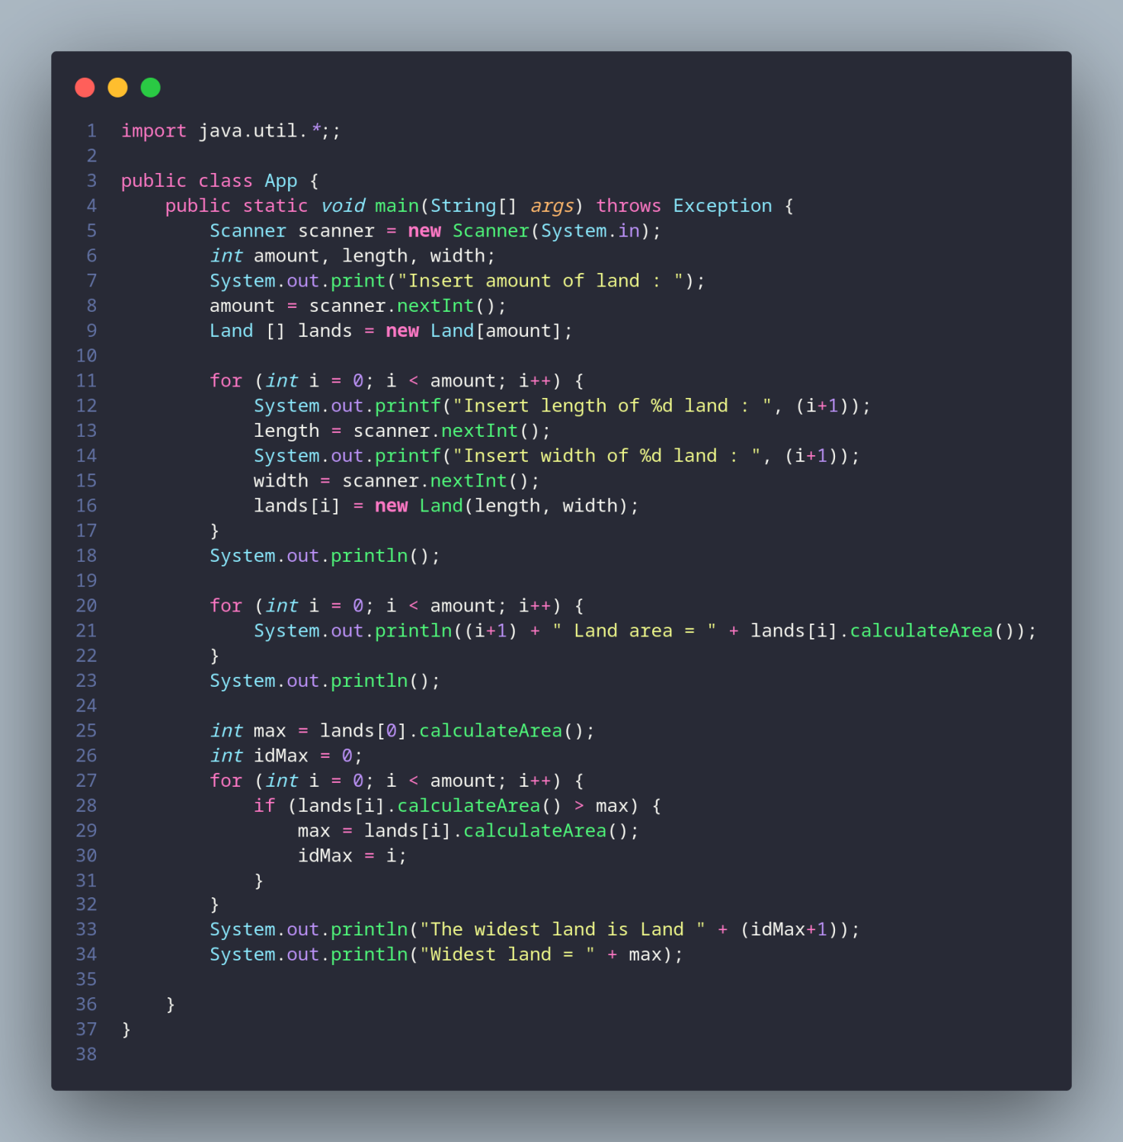

Result:

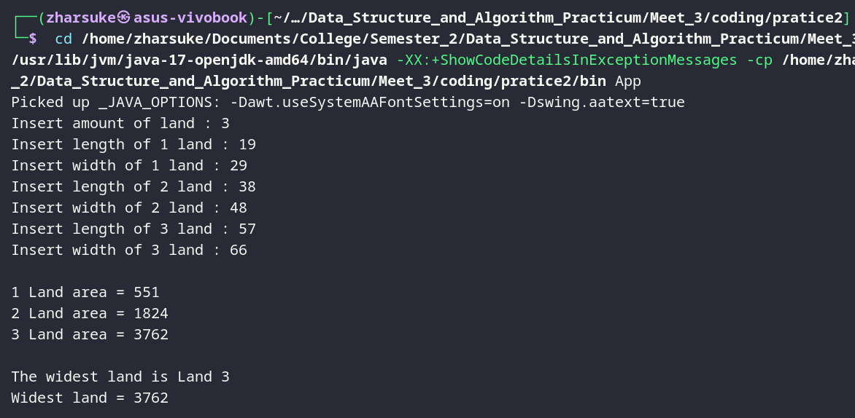

* + 1. A university needs a program to display student’s information such as name, nim, gender, and GPA. This program should be able to receive input from all of those informations and display it to the user. Implement the program if there is 3 data sample, here is a reference of how you do it:

Insert 1st student data Insert name :Rina Insert nim :1234567 Insert gender :P Insert IPK :3.5

Insert 2nd student data Insert name :Rio Insert nim :7654321 Insert gender:L

Insert IPK :4.0

Insert 3rd student data Insert name :Reza Insert nim :8765398 Insert gender:L

Insert IPK :3.8

Result:

1st Student Data name : Rina

nim : 1234567

gender: P

IPK score: 3.5

2nd Student Data name : Rio

nim : 7654321

gender: L

IPK score: 4.0 3rd student Data

name : Reza nim : 8765398

gender: L

IPK score: 3.8

Code:

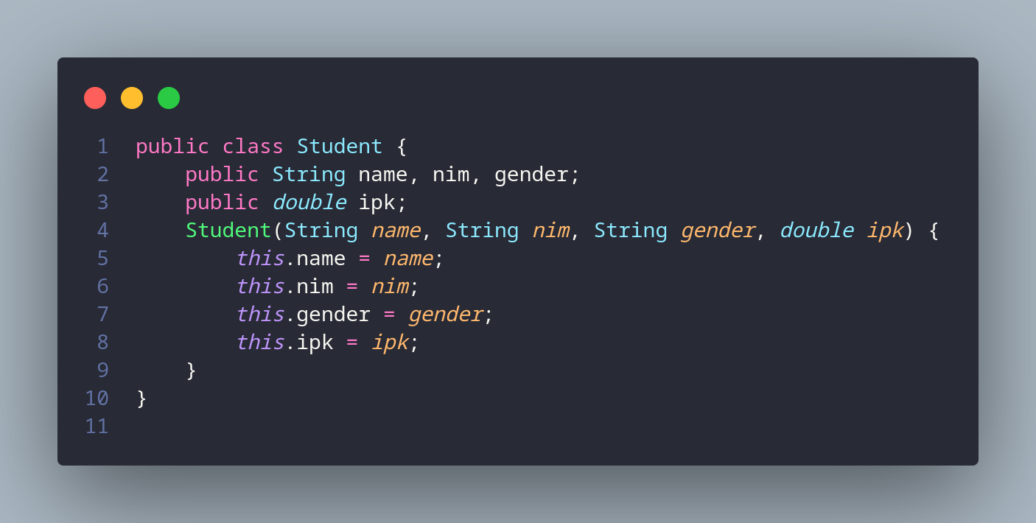

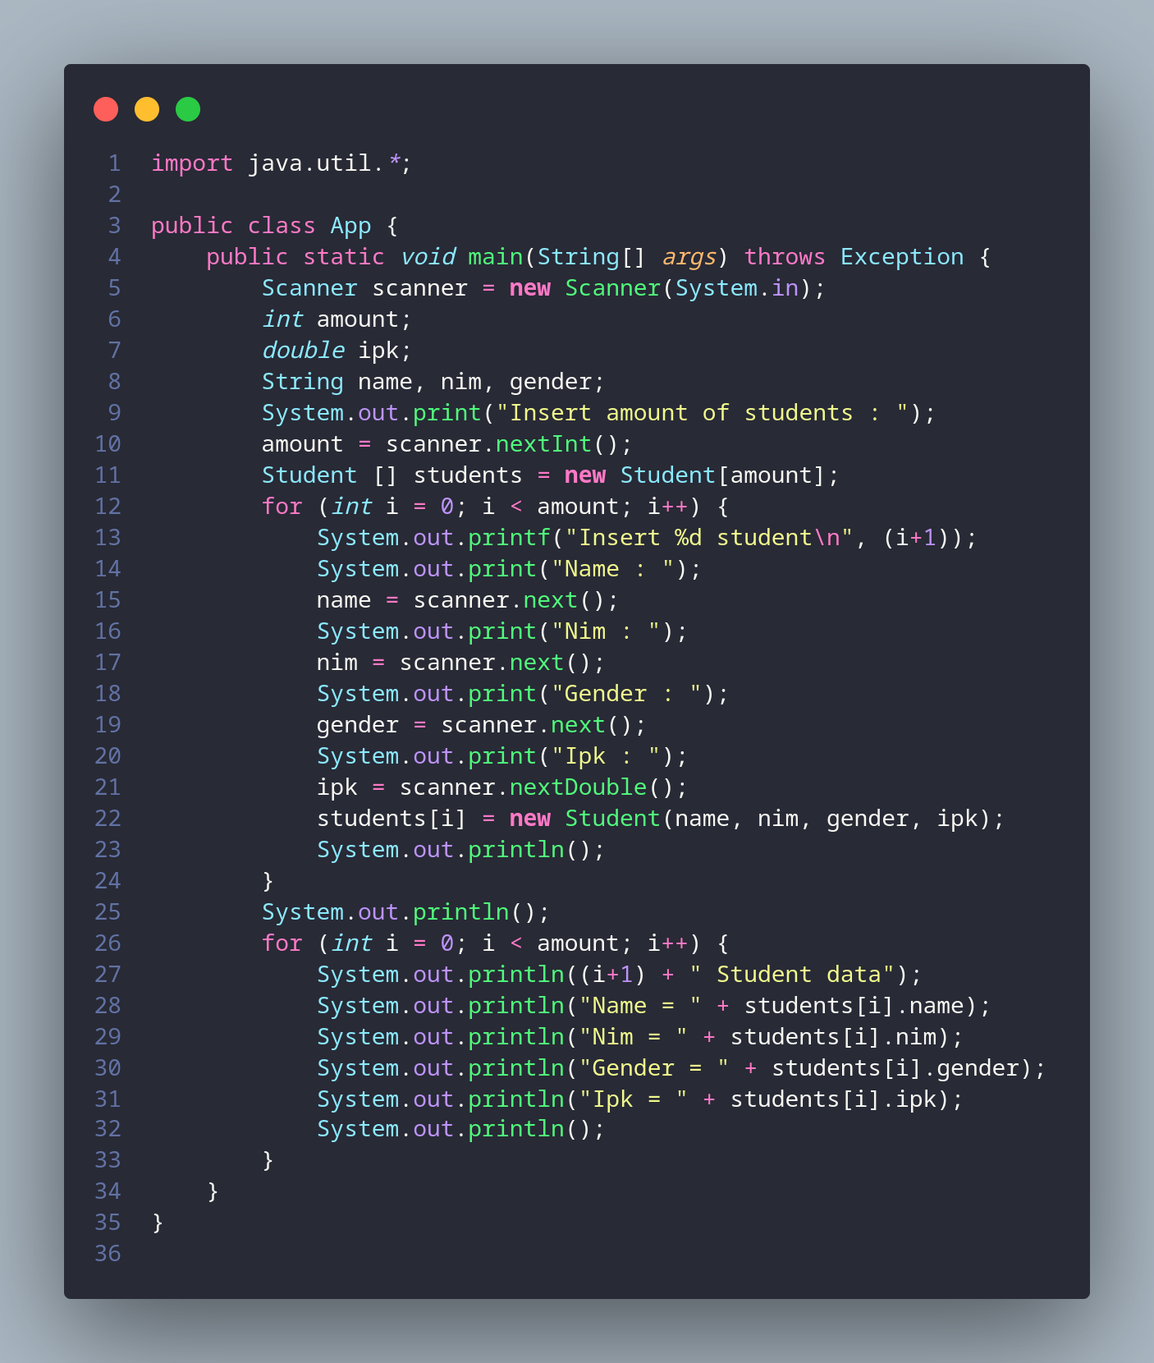

Result:

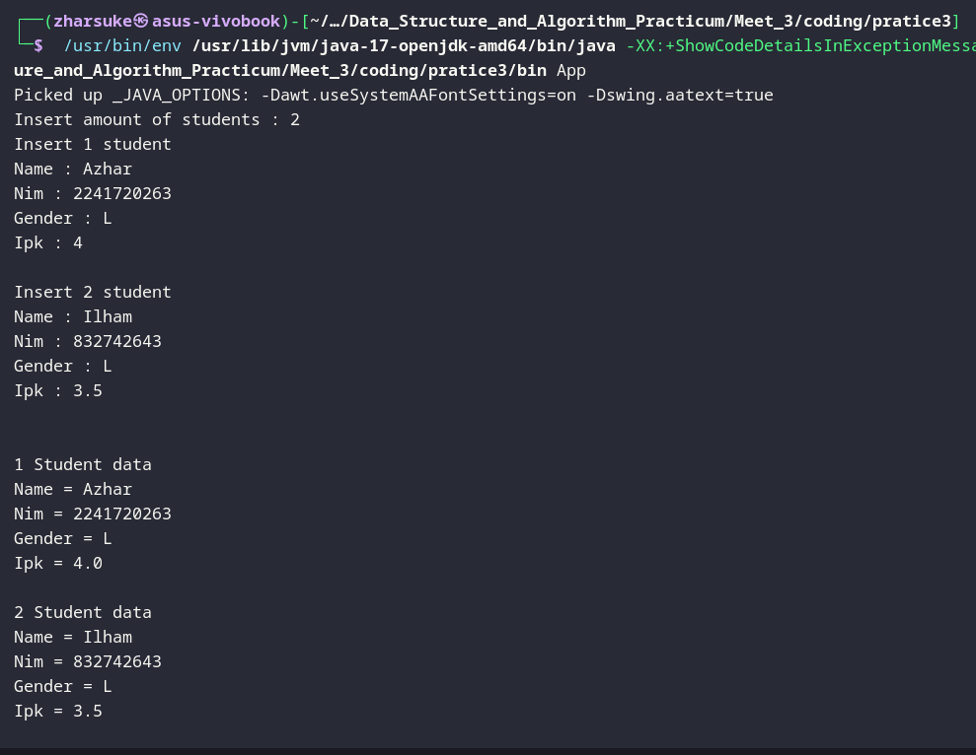

* + 1. Modify the program above so that it can receive the average of IPK score from all students. (Note: create a new function to calculate the average of IPK Score in class **Students**)

Insert 1st student data Insert name :Rina Insert nim :1234567 Insert gender :P Insert IPK :3.5

Insert 2nd student data Insert name :Rio Insert nim :7654321 Insert gender:L

Insert IPK :4.0

Insert 3rd student data Insert name :Reza Insert nim :8765398 Insert gender:L

Insert IPK :3.8

Result:

1st Student Data name : Rina

nim : 1234567

gender: P

IPK score: 3.5

2nd Student Data name : Rio

nim : 7654321

gender: L

IPK score: 4.0

3rd student Data name : Reza

nim : 8765398

gender: L

IPK score: 3.8

Average IPK of all students : 3.7666667

Code:



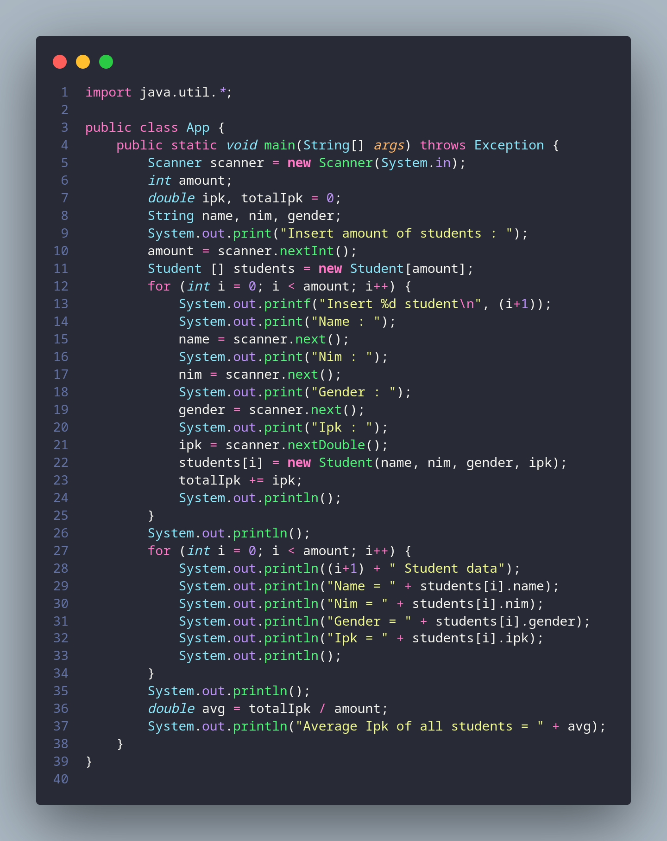

Result:

